LaTisha Burna
CS 330
12/11/2025
Final Project

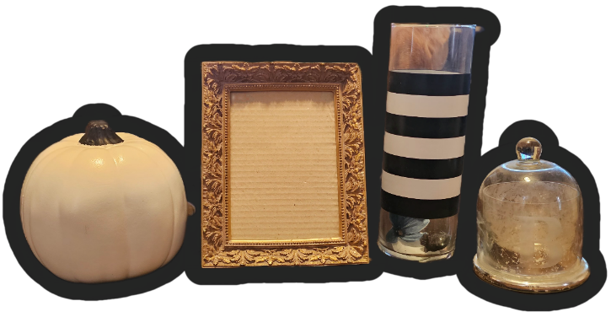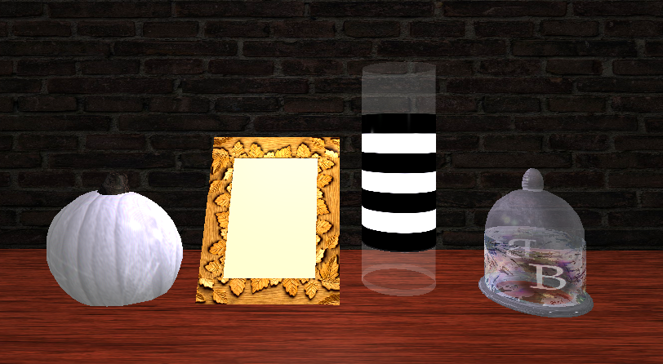
Figure 1. Project Proposal Reference Image
Original reference image selected for the project, showing the tabletop photo display scene used to guide object selection, layout, and overall visual style.
Figure 2. Final 3D Scene Implementation
Completed OpenGL 3D scene replicating the reference image, demonstrating object modeling, transformations, texturing, lighting, and material application.
Reflection
Development Choices
The goal of this project was to replicate a tabletop photo display scene while balancing visual accuracy with technical feasibility in OpenGL. I selected objects that could be represented using a combination of basic 3D shapes, which allowed me to focus on transformations, texturing, lighting, and materials rather than overly complex geometry. The scene includes a pumpkin, a photo frame, a striped glass vase, and a glass dome candle holder placed on a flat surface to represent a table.
Each object was intentionally chosen to demonstrate different modeling and rendering techniques. The pumpkin was created using a sphere for the main body and a tapered cylinder for the stem, which produces a recognizable organic form while remaining simple to implement. The photo frame uses box meshes to construct the frame pieces, while the picture inside the frame uses different colors on individual faces to prevent unwanted visibility from side angles. This approach allowed me to apply a complex texturing concept without relying entirely on image textures.
The striped vase was created using a cylinder with separate rendering for the sides, top, and bottom. This allowed me to apply different textures to different parts of the same object, satisfying the complex texturing requirement while improving realism. The candle holder, which quickly became the most challenging object to create, combines multiple shapes, including a torus, cylinder, and spheres, and uses a texture overlay technique on the cylinder body. A base texture and a transparent overlay texture were combined to simulate a decorative label effect, demonstrating layered texture rendering.
Overall, these development choices allowed me to meet project requirements while keeping the scene visually balanced, organized, and technically achievable within the scope of the course.

Navigation
User navigation within the 3D scene is controlled through a virtual camera system that allows movement and viewpoint changes. The camera is configured to respond to keyboard and mouse input, allowing the user to explore the scene from different angles and distances. Keyboard controls allow forward, backward, and lateral movement, while mouse input controls camera rotation and viewing direction.
This navigation setup allows the user to inspect each object in the scene closely and from multiple perspectives. This is useful for viewing applied textures, lighting effects, and object depth. The camera controls were implemented to feel smooth and intuitive, ensuring that movement does not interfere with the user’s ability to observe the scene clearly.

Custom Functions
Several custom functions were used to improve code organization, modularity, and reuse. Functions such as SetTransformations, SetShaderTexture, SetShaderTextureOverlay, SetShaderMaterial, and SetTextureUVScale were reused throughout the rendering process to keep the code consistent and readable.
The SetTransformations function handles scaling, rotation, and translation in a single place, reducing repeated logic and minimizing errors. Texture and material functions separate rendering responsibilities, making it easy to apply or modify textures, overlays, and material properties as needed.
Overall, this modular structure reduces code duplication, improves maintainability, and allows the same functions to be reused in future OpenGL projects.

